Exercise 2: E-commerce Platform Search Function
Scenario:
You are working on the search functionality of an e-commerce platform. The search needs to be optimized for fast performance.
Steps:
- Understand Asymptotic Notation:
  - Explain Big O notation and how it helps in analyzing algorithms.
Big O notation helps us to analyze the time and space complexity of the program based on the given input.
  - Describe the best, average, and worst-case scenarios for search operations.
For Linear Search:
Best Case: when the element found at the first positition.
Average Case: when the element is at the middle .
Worst Case: when the element is not in the array.
For Binary Search;
Best Case : The middle element is the target element.
Average Case: Search space halves every step.
Worst Case: Element absent or found after maximum comparisons.

- Setup:
  - Create a class Product with attributes for searching, such as productId, productName, and category.
class Products {

int productId;
String productName;
String category;

Products(int productId, String productName, String category) {
this.productId = productId;
this.productName = productName;
this.category = category;
}

void display() {
System.out.println(productId + " " + productName + " " + category);
}
}

- Implementation:
  - Implement linear search and binary search algorithms.
  - Store products in an array for linear search and a sorted array for binary search.
public class LinearSearchDemo {

static Products linearSearch(Products[] products, String key) {

for(Products p : products) {
if(p.productName.equalsIgnoreCase(key)) {
return p;
}
}

return null;
}

public static void main(String[] args) {

Products products[] = {

new Products(101,"Laptop","Electronics"),
new Products(102,"Mouse","Electronics"),
new Products(103,"Shoes","Fashion"),
new Products(104,"Phone","Electronics")
};

Products result = linearSearch(products,"Shoes");

if(result!=null)
result.display();
else
System.out.println("Product Not Found");

}

}

- Analysis:
  - Compare the time complexity of linear and binary search algorithms.
  - Discuss which algorithm is more suitable for your platform and why.
Output:
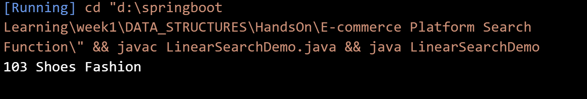

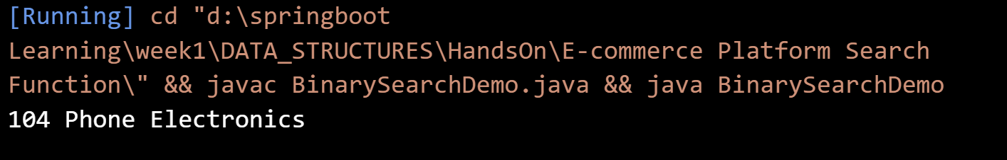

Exercise 7: Financial Forecasting
Scenario:
You are developing a financial forecasting tool that predicts future values based on past data.
Steps:
- Understand Recursive Algorithms:
  - Explain the concept of recursion and how it can simplify certain problems.
- Setup:
  - Create a method to calculate the future value using a recursive approach.

- Implementation:
  - Implement a recursive algorithm to predict future values based on past growth rates.
public class FinancialForecast {

static double forecast(double currentValue,double growthRate,int years){

if(years==0)
return currentValue;

return forecast(currentValue*(1+growthRate),growthRate,years-1);

}

public static void main(String[] args){

double current=1000;

double growth=0.10;

int years=5;

double future=forecast(current,growth,years);

System.out.println("Future Value = "+future);

}

}

- Analysis:
  - Discuss the time complexity of your recursive algorithm.
  - Explain how to optimize the recursive solution to avoid excessive computation.
